**RAIN**

**Web Based Internship Vacancy Application**

**R E A D Y F O R I N T E R N S H I P**



 **P B L - T R P L 1 0 9 ** **2 0 2 5**

**Meet Our Team**



**Leader**

**Eric Marchelino Hutabarat 4342401060**

**UI/ UX Designer & Tester**



**Wasyn Sulaiman Siregar 43424010**

**Frontend Developer**



**Indria Bintani Aiska 43424010**

**Backend Developer**



**Muhammad Aidil J. Saleh 43424010**

**Analyst**



**Fito Desta Fabiansah 43424010**

**Analyst**



**Winda Tri Wulan Dari 43424010**

**Analyst**



**What is “Ready for Internship”?**

The Web Based Internship Vacancy Application or “Ready for Internship” is a digital platform specifically designed to facilitate the internship recruitment process. This web based application was created with the aim of providing services to Polibatam students and companies in carrying out the internship recruitment process.

**Software Features**

Some of Our Application Features are :

 Search by Vacancy Title  Filter with 3 Categories  Vacancy Posting

 Vacancy Management

 Applicant Management  Account Management

 Profile Management

 Application and Interview Status



 



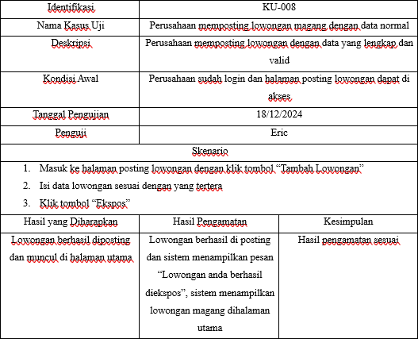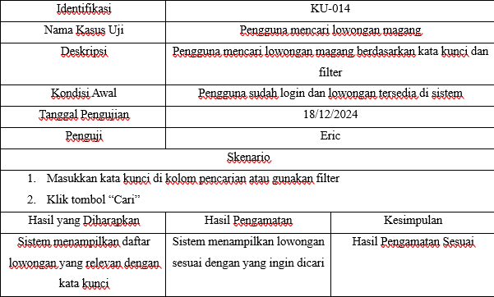**RAIN**

**Software Testing Results**

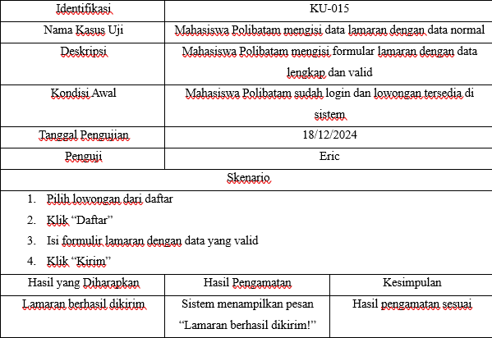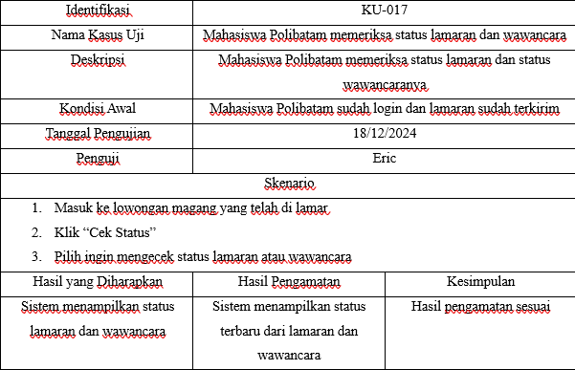

**Software Relationships With Subjects**

**RPL101**

This Web application was created by performing the stages of software development, as well as documenting and presenting it

**Introduction to Software Engineering**

**RPL104**

The requirements present in this Web Application are validated in the form of SRS or

documents

**Software Requirements**

**Analysis and Specification**

**RPL105**

Coding in this web application based on requirements using web-based programming

languages

**Web Based Programming**

**RPL106**

The database in this Application is based on requirements supported by

ERD

**Introduction to Databases**



**So, what is the conclusion of this product?**

This Web based Internship Vacancy Application called “Ready for Internship” was created by the PBL-TRPL109 team. Overall, the implementation of the RAIN web application will help simplify the internship recruitment process, providing significant benefits in efficiency and coordination in the internship recruitment process.

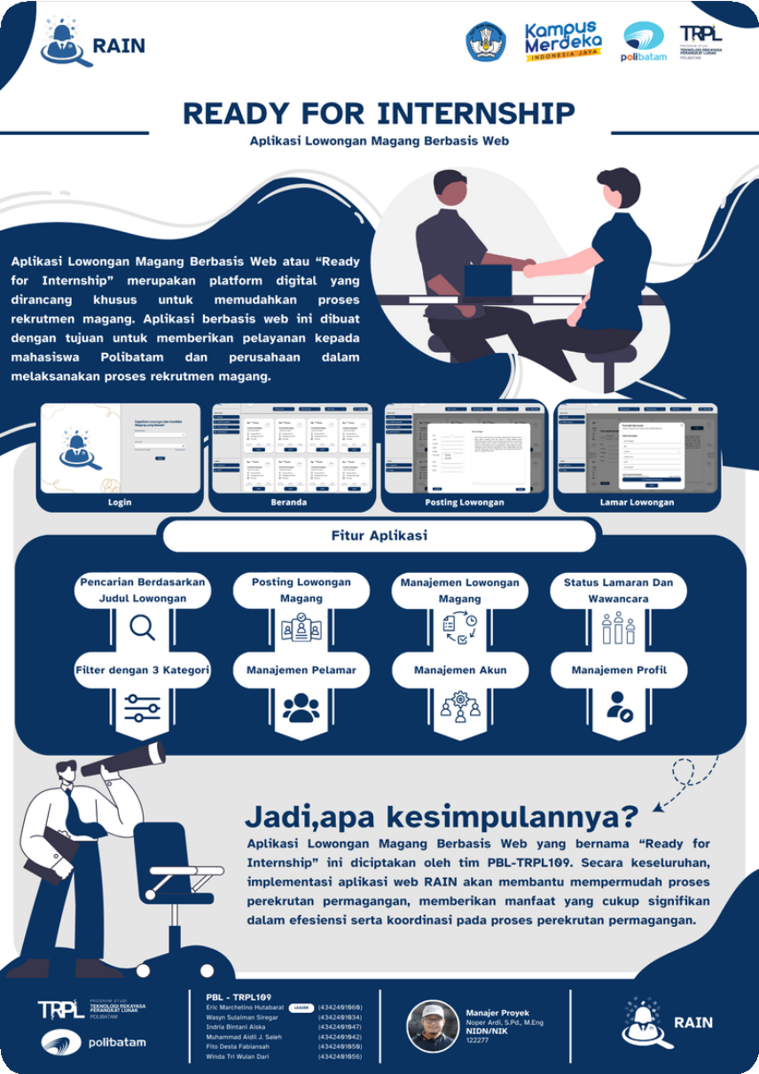

**P O S T E R**